NotesHub
(noteshub.co.in)

Software Engineering Lab File
5th Semester

To contribute, mail the files or contact us at support@noteshub.co.in

EXERCISE – 1
AIM:-
To write the problem statement of STUDENT RESULT MANAGEMENT SYSTEM.
REQUIREMENTS:-
- SOFTWARE REQUIREMENT – Microsoft Word
- HARDWARE REQUIREMENT – Computer, Keyboard, Mouse, CPU
THEORY:-
A university conducts 8 – semester B.Tech program divided into 4 branches namely CSE, IT, ECE and EEE. The students are offered 6 theory papers and 5 lab papers in all semesters. The theory papers offered in the 4th year are categorized as either ‘Core’ or ‘Elective’. Core papers do not have alternative subject whereas elective papers have 2 other alternative subjects. Thus, a student can take up any subject out of the 3 given choices.
The evaluation of each subject is done out of 100 marks. For theory paper, the division is 75+25 for externals and internals respectively. For lab paper, the division is 60+40 for externals and internals respectively. During the semester, minor exams are conducted for each semester. Students are also required to submit assignments as directed by the corresponding faculty and maintain Lab records for practicals. Based on the students’ performance in minor exams, assignments, Lab records and attendance, marks are given out of 25 in theory paper and 40 in lab paper. These marks account for internal evaluation if the students. At the end of each semester major exams are conducted in each subject (theory as well as practical). The theory papers are evaluated out of 75 marks and lab papers are evaluated out of 60 marks. Thus, the total marks of a student in a subject are obtained by adding the marks obtained in internal and external evaluation.
The students are required to submit a minor project report based on their summer training in 5th semester and a major report based in other summer training in 7th semester. These are evaluated out of 100 marks based on the report submitted, the presentation given and the viva response.
Every subject has some credits assigned to it. If the total marks of a student are >=50, he/she is considered ‘PASS’ otherwise ‘FAIL’. If the student is fail in a subject, he/she has to reappear for the subject next year in order to earn the credits.
It is required to develop a system that will manage information about subjects offered in various semesters, students enrolled in various semesters, electives opted by the students and marks and credit points obtained by the students in different semesters. The system should also have the ability to generate mark sheet for each student semester-wise. Semester-wise detailed marks list and student performance report also need to be generated.
CONCLUSION:-
Problem statement of STUDENT RESULT MANAGEMENT SYSTEM has been written successfully.

EXERCISE – 2
AIM:-
To do the requirement analysis and develop Software Requirement Specification Sheet forSTUDENT RESULT MANAGEMENT SYSTEM.
REQUIREMENTS:-
- SOFTWARE REQUIREMENT – Microsoft Word
- HARDWARE REQUIREMENT – Computer, Keyboard, Mouse, CPU
THEORY:-
- INTRODUCTION
This document aims at defining the overall software requirements for STUDENT RESULT MANAGEMENT SYSTEM. Efforts have been made to define the requirements exhaustively and accurately. The final product will be having only features/functionalities mentioned in this document and assumptions for any additional functionality/feature should not be made by any of the parties involved in developing/testing/implementing/using this product. In case it is required to have some additional features, a formal change request will need to be raised and subsequently a new release of this document and/or product will be produced.

  - PURPOSE
This specification document describes the capabilities that will be provided by the software application STUDENT RESULT MANAGEMENT SYSTEM. It also states the various required constraints by which the system will abide. The intended audiences for this document are the development team, testing team and end users of the product.

  - SCOPE
The software product STUDENT RESULT MANAGEMENT SYSTEM will be an MIS and Reporting application that will be used for result preparation and management of B. Tech Program of a University. The application will manage the information about various students enrolled in this course in different years, the subjects offered during different semesters of the course, the students’ choices for opting different subjects, and the marks obtained by various students in various subjects in different semesters. Printable reports regarding the list of students marks obtained by all students in a particular semester and performance of students (rank-wise, percentage-wise, pass/fail) will be generated. The system will also generate printable mark-sheets for individual students.
The application will greatly simplify and speed up the result preparation and management process.

  - DEFINITIONS, ACRONYMS AND ABBREVATIONS
Following abbreviations have been used throughout this document:-
B. Tech | Bachelor of Technology
CSE | Computer Science Engineering
IT | Information Technology
EEE | Electrical and Electronic Engineering
ECE | Electronics and Communication Engineering
DBA | Database Administrator
SRMS | Student Result Management System

  - REFERENCES
- University website: For information about course structure of B. Tech Program
- IEEE Recommended Practice for Software Requirement Specifications – IEEE Std 830-1993

  - OVERVIEW
The rest of this SRS document describes the various system requirements, interfaces, features and functionalities in detail.

- OVERALL DESCRIPTION
B. Tech Program is a 8-semester course.The students are offered 6 theory papers and 5 lab papers in all semesters. The students are required to submit a minor project report based on their summer training in 5th semester and a major report based in other summer training in 7th semester. Each subject/lab/term paper has credits associated with it. When a student secures pass marks in a paper he/she also earns all the credit(s) assigned tothat paper.
The SRMS will have the capability to maintain information about students enrolled in the course, the subjects offered to students in different semesters, the students’ choices for opting different elective subjects (out of the available ones) and the marks obtained by students in different subjects in various semesters. The software will also generate summary reports regarding student information, semester-wise mark lists and performance reports. Printable mark-sheets of individual students will also be generated by the application.

  - PRODUCT PERSPECTIVE
The application will be a windows-based self-contained and independent software product.
Backend
Database
Front End Client Application (with data entry/update/delete/view and reporting facility)

    - SYSTEM INTERFACES
None
    - USER INTERFACES
The application will have a user-friendly and menu based interface. Following screens will be provided:
- A Login screen for entering the username, password and role (Administrator, Data Entry Operator, Marks Entry Clerk, Coordinator) will be provided. Access to different screens will be based on the role of the user.
- There will be a screen for capturing and displaying information regarding what all subjects are offered during which semester and in which branch(es), how many credit points are assigned to that subject and whether the subject is an elective paper, a core paper or a term paper.
- There will be a screen for capturing and displaying information regarding various students enrolled in the course in different branches and different years.
- There will be screen for capturing and displaying information regarding which student is currently enrolled in which branch and semester and the subjects opted by them.
- There will be a screen that will capture information regarding which student has scored how many marks (internal + external evaluation) in each subject (in a particular semester). Credits in each subject will be calculated depending on the marks obtained in that subject.
- There will be a screen for capturing and displaying information regarding which all user accounts exist in the system, thus showing who all can access the system.
The following reports will be generated:-
- Students’ List Report: Printable reports will be generated to show the list of students enrolled in a particular batch year and in a particular branch.
- Students’ Subject Choices Report: For 7th and 8th semester, there will be a printable report showing the different elective subjects opted by various students (enrolled in a particular batch year and in a particular branch) of the corresponding semester.
- Marks List Report: for each semester there will be a printable report showing the subject-wise marks details for all students of that semester in a particular branch.
- Rank-wise List Report: for each semester and branch, there will be a printable report showing the percent-wise and rank-wise list of students along with the division secured.
- Mark-sheet: For each student of each semester and branch, a printable mark-sheet will be generated, showing the subject-wise marks details, total marks, total credits, percentage, pass/fail status for that student.

    - HARDWARE INTERFACES
- Screen resolution of atleast 800*600 – required for proper and complete viewing of screens. Higher resolutions will not be a problem.
- Support for printer (any type), that is, appropriate drivers are installed and printer connected to the system will be required for printing of reports and mark-sheets.
- Standalone system or network based – not a concern, as it will be possible to run the application on any of these.

    - SOFTWARE INTERFACES
- Any windows based operating system
- Oracle 10g Express Edition as DBMS – for database
- Crystal Reports 8 – for generating and viewing reports
- JDK 8 and NetBeans 8 – for coding/developing the software
Software mentioned in points (iii) and (iv) above will be required only for the development of the application. The final application will be packaged as an independent setup program that will be delivered to the client (University in this case).

    - COMMUNICATION INTERFACES
None

    - MEMORY CONSTRAINTS
Atleast 4GB RAM and 16GB space on hard disk will be required for running the application.

    - OPERATIONS
This product release will not only cover any automated housekeeping aspects of the database. DBA at the client site will be responsible for manually deleting old/non-required data. Database backup and recovery will also have to be handled by the DBA.
However, the system will provide a ‘RESET SYSTEM’ function that will delete (upon confirmation from the Administrator) all the existing data from the database.

    - SITE ADAPTATION REQUIREMENTS
The terminals at the client site will have to support the hardware and software interfaces specified in the above sections.

  - PRODUCT FUNCTIONS
The system will allow access only to authorized users with specified roles (Administrator, Data Entry Operator Marks Entry Clerk and Coordinator). Depending upon the user’s role, he/she will be able to access only specific modules of the system.
A summary of the major functions that the software will perform:-
- A Login facility for enabling only authorized users to access the system
- User (with role Data Entry Operator) will be able to add/modify/delete information about different students that are enrolled for the course in different years and different branches.
- User (with role Data Entry Operator) will be able to add/modify/delete information about different subjects that are offered in a particular semester in a given branch. The list for the same will also be displayed.
- User (with role Data Entry Operator) will be able to add/modify/delete information about the elective subjects opted by different students in 7th and 8th semester.
- User (with role Marks Entry Clerk) will be able to add/modify/delete information regarding marks obtained by different students in different semesters.
- User (with role Marks Entry Clerk) will also be able to print mark-sheets of students.
- User (with role Coordinator) will be able to generate printable reports (as mentioned in section 2.1.2 above.
- User (with role Administrator) will be able to ‘Reset’ the system – leading to deletion of all existing information from the backend database.
- User (with role Administrator) will be able to add/modify/delete new/existing user accounts.

  - USER CHARACTERISTICS
- Educational Level: Atleast graduate should be comfortable with English language.
- Experience: Should be well versed/informed about the course structure of B. Tech program of University. Entry of marks or their modification can be done only by user who is authorized for this job by the result preparation committee of the university.
- Technical Expertise: Should be comfortable using general-purpose applications on a computer.

  - CONSTRAINTS
- Due to limited features of DBMS being used, performance tuning features will not be applied to the queries and thus the system may become slow with the increase in number of records being stored.
- Due to limited features of DBMS being used, database auditing will also not be provided.
- Users at University will have to implement a security policy to safe-guard the marks-related information from being modified by unauthorized users (by means of gaining access to the backend database).

  - ASSUMPTIONS AND DEPENDENCIES
- The number of subjects to be taken up by a student in each semester does not change.
- The subject types do not change.
- The number of semesters in B. tech program does not change.

  - APPORTIONING OF REQUIREMENTS
Not required.

- SPECIFIC REQUIREMENTS
This section contains the software requirements to a level of detail sufficient to enable designers to design the system, and testers to test the system.

  - EXTERNAL INTERFACE REQUIREMENTS

    - USER INTERFACES
The following screens will be provided:-
LOGIN SCREEN
This will be the first screen that will be displayed. It will allow user to access different screens based upon the user’s role. Various fields available on this screen will be:-
- User ID: Alphanumeric of length upto 10 characters
- Password: Alphanumeric of length upto 8 characters
- Role: Will have the following values: Administrator, Marks Entry Clerk, Coordinator, Data Entry Operator
SUBJECT INFO PARAMETERS SCREEN
This screen will be accessible only to the user with role Administrator. It will allow the user to enter the semester number for which the user wants to access the subject information.
SUBJECT INFORMATION SCREEN
This screen will be accessible only to the user with role administrator. It allows user to add/modify/delete information about new/existing subject(s) for the semester that was selected in ‘Subject Info Parameters’ screen. The list of available for that semester will also be displayed. Various fields available on this screen will be:-
- Subject Code: of the format ETCS/ETEE/ETIT/ETEC - ### (# represents a digit
- Subject Name: Alphanumeric of length upto 50 characters
- Type: Will have any of the following values: Elective1/Elective2/Core/Lab/TermPaper
- Credits: Numeric will have any value from 0 to 20
STUDENT INFO PARAMETERS SCREEN
This screen will be accessible only to the user with role Administrator. It will allow the user to enter Batch Year and Branch for which the user wants to access the student information.
STUDENT INFORMATION SCREEN
This screen will be accessible only to user Administrator. It will allow the user to add/modify/delete information about new/existing student(s) for a particular Batch Year and Branch. Lists of students according to Batch year and Branch will also be displayed.Various fields available on these screens will be:-
- Enrollment No.: of the format ###(college code)(branch code)YY (# represents a digit and YY represents batch year)
- Name: will have only alphabetic letters and length upto 40 characters
- Branch: will take one of the following values: CSE, IT, ECE, EEE
- Batch Year: of the format YYYY (representing the year in which the student enrolled for the course
STUDENTS’ SUBJECT CHOICE PARAMETERS SCREEN
This screen will be accessible to user with role Administrator. It will allow the user to enter the Batch Year, Branch and semester number (7 or 8) for which the user wants to access the students’ subject choice information.
STUDENTS’ SUBJECT CHOICE INFORMATION SCREEN
This screen will be accessible to user with role Administrator. It will allow the user to add/modify/delete students’ choices for elective subjects of the semester, branch and batch year selected in the ‘Students’ Subject Choice Parameters’ screen. For the selected semester and branch it will display the list of students of available choices for Elective I and for Elective II. The screen will display the list of students enrolled during the selected batch year and currently studying in the selected semester and branch and the user will be able to view/add/modify/delete the subject choices for each student in the list.
MARKS ENTRY PARAMETERS SCREEN
This screen will be accessible to user with role Marks Entry Clerk. It will allow the user to enter the Batch Year, Branch and the subject for which the user wants to access the marks information.
MARKS ENTRY SCREEN
This screen will be accessible to user with role Marks Entry Clerk. It will allow the user to add/modify/delete information about marks obtained in the selected subjects by different students of that semester and branch who were enrolled in the given batch year selected in the ‘Marks Entry Parameters’ screen. The screen will display the list of students enrolled during the selected batch year and in selected branch and currently studying the selected subject in the selected semester and the user will be able to view/add/modify/delete the marks for each student in the list.
Various fields available on this screen will be:-
- Enrollment No.: will display the enrollment numbers of all the students selected batch year, and branch studying the selected subject in the selected semester.
- Name: will display name of the student
- Internal Marks: between 0 to 40 for lab paper and between 0 to 25 for core/elective paper
- External Marks: between 0 to 60 for lab paper and between 0 to 75 for core/elective paper
- Total Marks: sum of Internal Marks and External Marks
MARK-SHEET PARAMETERS SCREEN
This screen will be accessible to user with role Marks Entry Clerk. It will allow the user to enter the enrollment number, branch and the semester number of the student for whom the user wants to view/print the mark-sheet.
STUDENTS LIST PARAMETERS SCREEN
This screen will be accessible to user with role Coordinator. It will allow the user to enter the Batch year and Branch for which the user wants to view/print the students list report.

MARKS LIST REPORT PARAMETERS SCREEN
This screen will be accessible to user with role Coordinator. It will allow the user to enter the Batch year, Branch and semester for which the user wants to print the marks list report.
RANK-WISE LIST REPORT PARAMETERS SCREEN
This screen will be accessible to user with role Coordinator. It will allow the user to enter the Batch Year, Branch and semester for which the user wants to view/print the rank-wise list report.
STUDENTS’ SUBJECT CHOICES LIST REPORT PARAMETERS SCREEN
This screen will be accessible to user with role Coordinator. It will allow the user to enter the Batch Year, Branch and the semester for which the user wants to view/print the students’ subject choice list report.

    - HARDWARE INTERFACES
As stated in Section 2.1.3.

    - SOFTWARE INTERFACES
As stated in Section 2.1.4.

    - COMMUNICATION INTERFACES
None

  - SYSTEM FEATURES

    - SUBJECT INFORMATION MAINTENANCE
DESCRIPTION
The system will maintain information about various subjects being offered during different semesters and in different branches of the course. The following information would be maintained for each subject: Subject Code, Subject Name, Subject Type (Elective1/Elective2/Core/Lab/TermPaper), Semester, Branch and Credits.
The system will allow creation/modification/deletion of new/existing subjects and have the ability to list all the available subjects for a particular semester and branch.
VALIDITY CHECKS
- Only user with role Data Entry Operator will be authorized to access the Subject Information Maintenance module.
- All semesters have 6 theory papers and 5 lab papers.
- The theory papers offered in the 7th and 8th semester are categorized as either ‘Core’ or ‘Elective’. There are 2 elective subjects.
- Subject Code will be unique for every subject.
- No 2 semesters will have same subject.
- Subject code cannot be blank.
- Subject Name cannot be blank.
- Credits cannot be blank.
- Subject Type cannot be blank.
- Semester cannot be blank.
- Branch cannot be blank.
SEQUENCING INFORMATION
Subject information for a particular semester and branch will have to be entered in the system before any student/marks information for that semester and branch can be entered.
ERROR HANDLING/RESPOSE TO ABNORMAL SITUATIONS
If any of the above validations/sequencing flow does not hold true, appropriate error messages will be prompted to the user to do the needful.

    - STUDENT INFORMATION MAINTENANCE
DESCRIPTION
The system will maintain information about different students in a particular batch year and branch. The following information will be maintained: Enrollment Number, Name, Semester, Branch,Contact Number and E-mail ID.
The system will also allow creation/modification/deletion of new/existing students and also have the ability to list all the students in a particular year and branch.
VALIDITY CHECKS
- Only the user with role Data Entry Operator will have authorized access to Student Information Maintenance module.
- Every student will have a unique Enrollment Number.
- Enrollment number cannot be blank
- Name cannot be blank.
- Branch cannot be blank.
- Semester cannot be blank,
- Contact Number cannot be blank.
- E-mail ID cannot be blank.
SEQUENCING INFORMATION
Student Information for a particular student will have to be entered in the system before any marks information can be entered for that student.
ERROR HANDLING/RESPOSE TO ABNORMAL SITUATIONS
If any of the above validations/sequencing flow does not hold true, appropriate error messages will be prompted to the user to do the needful.

    - STUDENTS’ SUBJECT CHOICES INFORMATION MAINTENANCE
DESCRIPTION
The system will maintain information about choice of different Elective subjects opted by various students of different enrollment years and branches in different semesters. The following information will be maintained: Enrollment Number, Name, Semester, Branch, Student’s Choice for Elective 1 subject and Student’s Choice for Elective 2 subject.
The system will also allow creation/modification/deletion of new/existing students and also have the ability to list all the students in a particular year and branch.

VALIDITY CHECKS
- Only the user with role Data Entry Operator will have authorized access to Students’ Subject Choice Information Maintenance module.
- Every student will have a unique Enrollment Number.
- Enrollment number cannot be blank
- Name cannot be blank.
- Branch cannot be blank.
SEQUENCING INFORMATION
Students’ Subject Choice Information for a particular student can be entered in the system only after Subject Information has been entered in the system for given semester and branch and the Student Information for that student has been entered in the system.
Students’ Subject Choice Information for a particular student will have to be entered in the system before any marks information can be entered for that student in the given semester and branch.
ERROR HANDLING/RESPOSE TO ABNORMAL SITUATIONS
If any of the above validations/sequencing flow does not hold true, appropriate error messages will be prompted to the user to do the needful.

    - MARKS INFORMATION MAINTENANCE
DESCRIPTION
The system will maintain information about marks obtained by various students of different enrollment years and branches in different semesters. The following information would be maintained: Enrollment Number, Semester, Branch, Subject Code, Internal Marks, External marks, Total marks and Credits.
The system will allow creation/modification/deletion of marks information and also have the ability to list all the available marks information for all students for a particular subject in the given semester and branch.
VALIDITY CHECKS
- Only user with role Marks Entry Clerk will have authorized access to Marks Information Maintenance module.
- Internal marks have to be between 0 to 25 for theory paper and between 0 to 40 for lab paper.
- External marks have to be between 0 to 75 for theory paper and between 0 to 60 for lab paper.
- Total marks = Internal marks + External marks
- If the total marks in a subject are >=50, all credit points associated with that subject will be given to the student, else the credit points earned by the student will be zero for that subject.
SEQUENCING INFORMATION
Marks information for a particular student can be entered in the system only after Subject information, Student information and Students’ Subject Choice information has been entered in the system for that student in the given semester and branch.
Marks information for a particular student will have to be entered in the system before that student’s mark-sheet can be generated.
ERROR HANDLING/RESPOSE TO ABNORMAL SITUATIONS
If any of the above validations/sequencing flow does not hold true, appropriate error messages will be prompted to the user to do the needful.

    - MARK-SHEET GENERATION
DESCRIPTION
The system will generate mark-sheet for every student in different semesters.
MARK-SHEET FORMAT
 |  | NAME OF UNIVERSITY
 |  | NAME OF PROGRAM
 |  | SEMESTER <no.>
 |  | BRANCH <name>
 |  | MARK-SHEET
 |  | ENROLLMENT No.:________________________ |  |  |  | NAME:____________________________
 |  | S. No. | THEORY/LAB | SUBJECT | INTERNAL | EXTERNAL | TOTAL | P/F | CREDITS
 |  | 1
 |  | 2
 |  | 3
 |  | 4
 |  | 5
 |  | 6
 |  | 7
 |  | 8
 |  | 9
 |  | 10
 |  | 11
 |  |  |  | MARKS GRAND TOTAL:_________/600 |  |  | TOTAL CREDITS:______________
 |  |  |  | RESULT:(pass/fail)
 |  | DATE:_______________
 |  |  |  |  |  | SIGNATURE OF CONTROLLER OF EXAMINATION

There will be a ‘PRINT’ icon at the top of the mark-sheet for printing it.
VALIDITY CHECKS
- Only user with role Marks Entry Clerk will be authorized to access the Mark-sheet Generation module.
SEQUENCING INFORMATION
Marks-sheet for a particular student can be generated by the system only after Subject information, Student information, Students’ Subject Choice information and Marks information has been entered for that student in the given semester and branch.
ERROR HANDLING/RESPOSE TO ABNORMAL SITUATIONS
If any of the above validations/sequencing flow does not hold true, appropriate error messages will be prompted to the user to do the needful.

    - REPORT GENERATION
STUDENT LIST REPORT
For each year, a branch-wise report will be generated containing the list of students enrolled in that batch year. Report format will be as shown below:-
 |  | NAME OF UNIVERSITY
 |  | NAME OF PROGRAM
 |  | BRANCH <NAME>
 |  | BATCH YEAR <YYYY>
 |  | S. No. | ENROLLMENT NUMBER | NAME
 |  | 1
 |  | 2
 |  | 3

STUDENTS’ SUBJECT CHOICES LIST REPORT
For each year, a branch-wise report will be generated containing the list of students of 4th year and their choices for Elective subjects in 7th or 8th semester. Report format will be as shown below:-
 | NAME OF UNIVERSITY
 | NAME OF PROGRAM
BRANCH <NAME>
SEMESTER <No>
 | S. No. | ENROLLMENT NUMBER | NAME | ELECTIVE 1 |  | ELECTIVE 2
 | S. No. | ENROLLMENT NUMBER | NAME | CODE | NAME | CODE | NAME
 | 1
 | 2
 | 3

SEMESTER-WISE MARK LIST
For each semester, a branch-wise report will be generated that will have total marks (= internal marks + external marks) of all students (enrolled in the selected Batch Year) of that semester in all subjects. Report format will be as shown below:-
 |  | NAME OF UNIVERSITY
 |  | NAME OF PROGRAM
 |  | BRANCH <NAME>
 |  | SEMESTER <No>
 |  | S. No. | ENROLLMENT NUMBER | SUBJECT 1 | SUBJECT 2 | SUBJECT 3 | SUBJECT 4 | SUBJECT 5 | SUBJECT 6
 |  | S. No. | ENROLLMENT NUMBER | TOTAL MARKS | TOTAL MARKS | TOTAL MARKS | TOTAL MARKS | TOTAL MARKS | TOTAL MARKS
 |  | 1
 |  | 2
 |  | 3

RANK-WISE LIST REPORT
This report will be generated branch-wise for each semester of every batch Year. The report will be sorted in increasing order of percentage/rank. Report format will be as shown below:-
 |  | NAME OF UNIVERSITY
 |  | NAME OF PROGRAM
 |  | BRANCH <NAME>
 |  | SEMESTER <No>
 |  | S. No. | ENROLLMENT NUMBER | NAME | GRAND TOTAL | PERCENTAGE | RANK | DIVISION
 |  | S. No. | ENROLLMENT NUMBER | NAME | MARKS | PERCENTAGE | RANK | DIVISION
 |  | 1
 |  | 2
 |  | 3
    - USER ACCOUNTS INFORMATION MAINTENANCE
DESCRIPTION
The system will maintain information about various users who will be able to access the system. The following information would be maintained: User Name, User ID, Password and Role.
VALIDITY CHECKS
- Only user with role Administrator will be authorized to access the User Accounts Information Maintenance module.
- User Name cannot be blank.
- User ID cannot be blank.
- User ID should be unique for every user.
- Password cannot be blank.
- Role cannot be blank.
SEQUENCING INFORMATION
User Account for a particular user has to be created in order for the system to be accessible to that user. At system startup, only a default user account for ‘Administrator’ would be present in the system.
ERROR HANDLING/RESPONSE TO ABNORMAL SITUATIONS
If any of the above validations/sequencing flow does not hold true, appropriate error messages will be prompted to the user to do the needful.

  - PREFORMANCE REQIREMENTS
None

  - DESIGN CONSTRAINTS
None

  - SOFTWARE SYSTEM ATTRIBUTES

    - SECURITY
The application will be password protected. Users will have to enter correct username, password and role in order to access the application.

    - MAINTAINABILITY
The application will be designed in a maintainable manner. It will be easy to incorporate new requirements in individual modules.

    - PORTABILITY
The application will be easily portable on any windows-based system that has Oracle 10g Express Edition installed.

  - LOGICAL DATABASE REQUIREMENTS
The following information will be placed in a database:
- Subject information: Subject name, Subject code, Branch, Credit points, Type and Semester
- Student information: Enrollment number, Name, Enrollment Year, Branch and Semester
- Students’ subject choice information: Enrollment number, Branch, Semester, Choice of Elective 1 subject and Choice of Elective 2 subject.
- Marks information: Enrollment number, Branch, Semester, Internal marks in each subject and External marks in each subject.
- User account information: User Name, User ID, Password and Role.

  - OTHER REQUIREMENTS
None

- CHANGE MANAGEMENT PROCESS
Changes in the system will be done as required by the customer. If any problem arises in the system, that also will be sought out as soon as possible.

- DOCUMENT APPROVALS
- Anureet Kaur Bhatia
- Anchal Bansal

- SUPPORTING INFORMATION
For more information, email us at the following address – unicomp@gmail.com.
CONCLUSION:-
Requirement analysis of STUDENT RESULT MANAGEMENT SYSTEM has been done and its Software Requirement Specification Sheet has been written successfully.

EXERCISE – 3
AIM:-
To draw the ER Diagram forSTUDENT RESULT MANAGEMENT SYSTEM.
REQUIREMENTS:-
- SOFTWARE REQUIREMENT – Microsoft Word, MS Paint
- HARDWARE REQUIREMENT – Computer, Keyboard, Mouse, CPU
THEORY:-
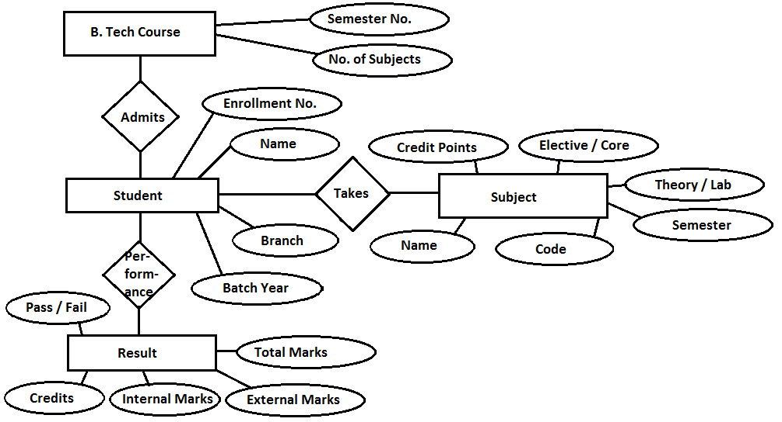
CONCLUSION:-
ER Diagram forSTUDENT RESULT MANAGEMENT SYSTEM has been drawn successfully.

EXERCISE – 4
AIM:-
To draw the Use Case Diagram forSTUDENT RESULT MANAGEMENT SYSTEM.
REQUIREMENTS:-
- SOFTWARE REQUIREMENT – Microsoft Word, Rational Rose Enterprise Edition
- HARDWARE REQUIREMENT – Computer, Keyboard, Mouse, CPU
THEORY:-
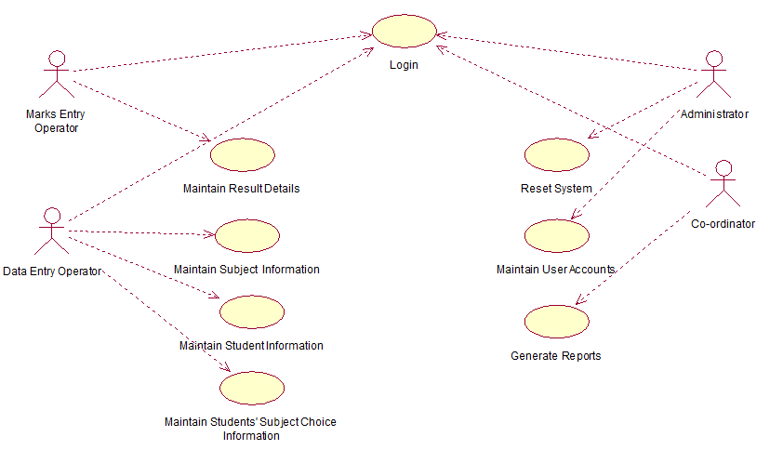
CONCLUSION:-
Use Case Diagram forSTUDENT RESULT MANAGEMENT SYSTEM has been drawn successfully.

EXERCISE – 4
AIM:-
To draw the Use Case Diagram forSTUDENT RESULT MANAGEMENT SYSTEM.
REQUIREMENTS:-
- SOFTWARE REQUIREMENT – Microsoft Word, Rational Rose Enterprise Edition
- HARDWARE REQUIREMENT – Computer, Keyboard, Mouse, CPU
THEORY:-
CONCLUSION:-
Use Case Diagram forSTUDENT RESULT MANAGEMENT SYSTEM has been drawn successfully.

EXERCISE – 5
AIM:-
To write the Use Case Description of STUDENT RESULT MANAGEMENT SYSTEM.
REQUIREMENTS:-
- SOFTWARE REQUIREMENT – Microsoft Word
- HARDWARE REQUIREMENT – Computer, Keyboard, Mouse, CPU
THEORY:-
- LOGIN
  - Brief Description
This use case describes how a user logs into the Student Result Management System.
  - Actors
- Data Entry Operator
- Marks Entry Clerk
- Administrator
- Coordinator
  - Pre – Conditions
All users must have a User Account (i.e., User Id, Password and Role) created for them in the system (through the Administrator), prior to executing the use cases.
  - Post – Conditions
If the use case was successful, the actor is logged into the system. If not, the system state remains unchanged,
If the actor has the role ‘Data Entry Operator’, he/she will have access to only screens corresponding to the Subject Info Maintenance, Student Info Maintenance and Students’ Subject Choice Info Maintenance modules of the system.
If the actor has the role ‘Marks Entry Clerk’, he/she will have access to only screens corresponding to the Marks Info Maintenance module of the system.
If the actor has the role ‘Coordinator’, he/she will only be able to view/print the various reports generated by the system.
If the actor has the role ‘Administrator’, he/she will have access to only screens corresponding to the User Account Maintenance module and Reset System feature of the system.
  - Flow of Events
    - Basic Flow
This use case starts when the actor wishes to log into the Student Result Management System.
- The system requests that the actor enter his/her name, password and role. The role can be any one of Data Entry Operator, Marks Entry Clerk, Administrator and Coordinator.
- The actor enters his/her name, password and role.
- The system validates the entered name, password, and role and logs the actor into the system.
    - Alternative Flow
      - Invalid Name/Password/Role
If in the basic flow, the actor enters an invalid name, password and/or role, the system displays an error message. The actor can choose to either return to the beginning of the basic flow or cancel the login, at which point the use case ends.
  - Special Requirements
None
  - Related Use Cases
None

- MAINTAIN STUDENT INFORMATION
  - Brief Description
This use case allows the actor to maintain student information. This includes adding, changing and deleting student information from the system.
  - Actors
Data Entry Operator
  - Pre – Conditions
The Data Entry Operator must be logged into the system before this use begins.
  - Post – Conditions
If the use case was successful, the student information is added, updated or deleted from the system. Otherwise, the system state is unchanged.
  - Flow of Events
    - Basic Flow
This use case starts when the Data Entry Operator wishes to add, change, and/or delete student information from the system.
- The system requests the Data Entry Operator to specify the function he/she would like to perform (Add a Student, Update a Student or Delete a Student).
- Once the Data Entry Operator provides the requested information, one of the sub – flows is executed:
- If the Data Entry Operator selected “Add a Student”, the Add a Student sub – flow is executed.
- If the Data Entry Operator selected “Update a Student”, the Update a Student sub – flow is executed.
- If the Data Entry Operator selected “Delete a Student”, the Delete a Student sub – flow is executed.
      - Add a Student
- The system requests that the Data Entry Operator enters the student information. This includes: Name, Enrollment Number (should be unique for every student), Branch, Year of Enrollment.
- Once the Data Entry Operator provides the requested information, the student is added to the system and appropriate message is displayed.
      - Update a Student
- The system requests that the Data Entry Operator enters the student enrollment number.
- The Data Entry Operator Enters the enrollment number. The system retrieves and displays the student information.
- The Data Entry Operator makes the desired changes to the student information. This includes any of the information specified in the Add a Student sub – flow.
- After the Data Entry Operator updates the necessary information, the system updates the student records with the updated information.
      - Delete a Student
- The system requests that the Data Entry Operator enters the enrollment number.
- The Data Entry Operator enters the enrollment number. The system retrieves and displays the student information.
- The system prompts the Data Entry Operator to confirm the deletion of the student.
- The Data Entry Operator confirms the deletion.
- The system deletes the student record.
    - Alternative Flow
      - Student Not Found
If in the Update a Student or Delete a Student sub – flows, a student with the specified enrollment number does not exist, the system displays an error message. The Data Entry Operator can then enter a different enrollment number or cancel the operation, at which point the use case ends.
      - Update Cancelled
If in the Update a Student sub – flow, the Data Entry Operator decides not to update the student information, the update is cancelled and the Basic Flow is re – started from the beginning.
      - Delete Cancelled
If in the Delete a Student sub – flow, the Data Entry Operator decides not to delete the student information, the delete is cancelled and the Basic Flow is re – started from the beginning.
  - Special Requirements
None
  - Related Use Cases
None

- MAINTAIN SUBJECT INFORMATION
  - Brief Description
This use case allows the actor to maintain subject information. This includes changing, adding and deleting subject information from the system.
  - Actors
Data Entry Operator
  - Pre – Conditions
The Data Entry Operator must be logged into the system before this use begins.
  - Post – Conditions
If the use case was successful, the subject information is added, updated or deleted from the system. Otherwise, the system state is unchanged.
  - Flow of Events
    - Basic Flow
This use case starts when the Data Entry Operator wishes to add, change, and/or delete subject information from the system.
- The system requests the Data Entry Operator to specify the function he/she would like to perform (Add a Subject, Update a Subject or Delete a Subject).
- Once the Data Entry Operator provides the requested information, one of the sub – flows is executed:
- If the Data Entry Operator selected “Add a Subject”, the Add a Subject sub – flow is executed.
- If the Data Entry Operator selected “Update a Subject”, the Update a Subject sub – flow is executed.
- If the Data Entry Operator selected “Delete a Subject”, the Delete a Subject sub – flow is executed.
      - Add a Student
- The system requests that the Data Entry Operator enters the student information. This includes: Name of the subject, Subject Code (should be unique for every student), Branch, Semester, Subject type (Core/Elective and Theory/Lab) and Credits.
- Once the Data Entry Operator provides the requested information, the subject is added to the system and appropriate message is displayed.
      - Update a Subject
- The system requests that the Data Entry Operator enters the subject code.
- The Data Entry Operator enters the subject code. The system retrieves and displays the subject information.
- The Data Entry Operator makes the desired changes to the subject information. This includes any of the information specified in the Add a Subject sub – flow.
- After the Data Entry Operator updates the necessary information, the system updates the subject records with the updated information.
      - Delete a Subject
- The system requests that the Data Entry Operator enters the subject code.
- The Data Entry Operator enters the subject code. The system retrieves and displays the subject information.
- The system prompts the Data Entry Operator to confirm the deletion of the subject.
- The Data Entry Operator confirms the deletion.
- The system deletes the subject record.
    - Alternative Flow
      - Subject Not Found
If in the Update a Subject or Delete a Subject sub – flows, a subject with the specified subject code does not exist, the system displays an error message. The Data Entry Operator can then enter a different subject code or cancel the operation, at which point the use case ends.
      - Update Cancelled
If in the Update a Subject sub – flow, the Data Entry Operator decides not to update the subject information, the update is cancelled and the Basic Flow is re – started from the beginning.
      - Delete Cancelled
If in the Delete a Subject sub – flow, the Data Entry Operator decides not to delete the subject information, the delete is cancelled and the Basic Flow is re – started from the beginning.
  - Special Requirements
None

  - Related Use Cases
None

- MAINTAIN STUDENTS’ SUBJECT CHOICE INFORMATION
  - Brief Description
This use case allows the actor to maintain information about the choice of different Elective subjects opted by various students. This includes displaying the various available choices of Elective subjects available during a particular semester and updating the information about the choice of Elective Subject(s) opted by different students of that semester.
  - Actors
Data Entry Operator
  - Pre – Conditions
The Data Entry Operator must be logged into the system before this use begins.
  - Post – Conditions
If the use case was successful, information about students’ choices for opting different Elective Subjects is added/updated in the system. Otherwise, the system state is unchanged.
  - Flow of Events
    - Basic Flow
This use case starts when the Data Entry Operator wishes to update Students’ Subject Choice Information in the system.
- The system requests that the Data Entry Operator Specify the Semester, Branch and Enrollment Year of students for whom the subject choices have to be updated.
- Once the Data Entry Operator provides the requested information, the system display the list of available choices for Elective-I and Elective-II for that semester and branch and the list of students enrolled in the given enrollment year and branch (along with their existing subject choices, if any).
- The system requests that the Data Entry Operator specify the information regarding Students’ Subject Choices. This includes:
- Student’s Enrollment Number
- Student’s choice for Elective I (corresponding subject code)
- Student’s choice for Elective II (corresponding subject code)
- Once the Data Entry Operator provides the requested information, the information regarding the Students’ Subject Choices is added/updated in the system and an appropriate message is displayed.

    - Alternative Flow
      - Subject Information Does Not Exist
If no or incomplete information exists in the system for semester and branch specified by the Data Entry Operator, the system displays an error message. The Data Entry operator can then enter a different semester and/or branch or cancel the operation, at which point the use case ends.
      - Student Information Does Not Exist
If no student information exists in the system for the enrollment year and branch specified by the Data Entry Operator, the system displays an error message. The Data Entry Operator can enter a different enrollment year and/or branch or cancel the operation, at which point the use case ends.
      - Incorrect Choice Entered For Elective I/Elective II
If the subject code entered by the Data Entry Operator for Elective I/Elective II does not exist in the system, the system displays an error message. The Data Entry Operator can enter the correct subject code, or cancel the operation, at which point the use case ends.
      - Update Cancelled
If in the Basic Flow, the Data Entry Operator decides not to update the subject information, the update is cancelled and the basic flow is restarted from the beginning.
  - Special Requirements
None
  - Related Use Cases
None

- MAINTAIN RESULT DETAILS
  - Brief Description
This use case allows the actor to maintain subject - wise marks information of each student, in different semesters. This includes adding, changing and deleting marks information from the system.
  - Actors
Marks Entry Clerk
  - Pre – Conditions
The Marks Entry Clerk must be logged into the system before this use case begins.
  - Post – Conditions
If the use case was successful, the marks information is added, updated or deleted from the system. Otherwise, the system state is unchanged.

  - Flow of Events
    - Basic Flow
This use case starts when the Marks Entry Clerk wishes to add, change and/or delete marks information from the system.
- The system requests that the Marks Entry Clerk specify the function that he/she would like to perform (Add Marks, Update Marks, Delete Marks or Generate Mark-sheet.
- Once the Marks Entry Clerk provides the requested information, one of the sub – flows is executed.
- If the marks Entry Clerk selected “Add Marks”, the Add Marks sub – flow is executed.
- If the marks Entry Clerk selected “Update Marks”, the Update Marks sub – flow is executed.
- If the marks Entry Clerk selected “Delete Marks”, the Delete Marks sub – flow is executed.
- If the marks Entry Clerk selected “Generate Mark-sheet”, the Generate Mark-sheet sub – flow is executed.
      - Add Marks Record
- The system requests that the Marks Entry Clerk enters the marks information. This includes: semester, branch, enrollment number, subject code, internal/external marks in the subject of given subject code.
- Once the Marks Entry Clerk provides the requested information, the system saves the marks and an appropriate message is displayed.
      - Update Marks Record
- The system requests the Marks Entry Clerk to make following entries: branch, semester, enrollment number, subject code for which the marks have to be updated.
- Once the Marks Entry Clerk provides the requested information, the system retrieves and displays the corresponding marks details.
- The Marks Entry Clerk makes the desired changes to the internal/external marks details.
- The system updates the marks record with the changes information.
      - Delete Marks Record
- The system requests the Marks Entry Clerk to make following entries: branch, semester, enrollment number, subject code for which the marks have to be deleted.
- Once the Marks Entry Clerk provides the requested information, the system retrieves and displays the corresponding marks details.
- The system verifies if the Marks Entry Clerk wishes to proceed with the deletion of the record. Upon conformation, the record is deleted from the system.
      - Compute Result
- Once all the marks are added to the database, the result is computed for each student.
- If the student has scored more than 50% in a subject, the associated credit points are allotted to that student.
- The average percentage marks are calculated for the student and his/her division is also derived based on the percentage.
      - Generate Mark-sheet
- The system requests that the Marks Entry Clerk specify the branch and enrollment number of the student and the semester for which mark-sheet is to be generated.
- Once the Marks Entry Clerk provides the requested information, the system generates a printable mark-sheet for the specified student and displays it.
- The Marks Entry Clerk can then issue a print request for the mark-sheet to be printed.
    - Alternative Flow
      - Record Not Found
If in the Update Marks, Delete Marks or Generate Mark-sheet sub – flows, the record with specified information does not exist, the system displays an error message. The Marks Entry Clerk can then enter different information for retrieving the record or cancel the operation, at which point the use case ends.
      - Updated Cancelled
If in the Update Marks sub – flow, the Marks Entry Clerk decides not to update the marks, the update is cancelled and the Basic Flow is re-started from the beginning.
      - Delete Cancelled
If in the Delete Marks sub – flow, the Marks Entry Clerk decides not to delete the marks, the delete is cancelled and the Basic Flow is re-started from the beginning.
  - Special Requirements
None
  - Related Use Cases
None
- GENERATE REPORTS
  - Brief Description
This use case allows the actor to generate various reports. The following reports can be generated:
- Student List Report
- Students’ Subject Choices List Report
- Marks List Report
- Rank – wise List Report
  - Actors
Coordinator
  - Pre – Conditions
The Coordinator must be logged into the system before this use case begins.
  - Post – Conditions
If the use case was successful, the desired report is generated. Otherwise the system state remains unchanged.
  - Flow of Events
    - Basic Flow
This use case starts when the Coordinator wishes to generate reports.
- The system requests the Coordinator to specify the report he/she would like to generate.
- Once the Coordinator provides the requested information, one of the sub – flows is executed:
- If the Coordinator selected “Student List Report”, the Generate Student List Report sub – flow is executed.
- If the Coordinator selected “Students’ Subject Choice List Report”, the Generate Students’ Subject Choice List Report sub – flow is executed.
- If the Coordinator selected “Marks List Report”, the Generate Marks List Report sub – flow is executed.
- If the Coordinator selected “Rank-wise List Report”, the Generate Rank-wise List Report sub – flow is executed.
      - Generate Student List Report
- The system requests that the Coordinator provide the branch and enrollment year for which the Student List Report is to be generated.
- Once the Coordinator provides the requested information, the system generates the Student List Report, containing the list of students enrolled in the given branch and the given year.
- The Coordinator can then issue a print request for the report to be printed.
      - Generate Students’ Subject Choices List Report
- The system requests that the Coordinator provides the branch, enrollment year and the semester for which the Students’ Subject Choices List Report is to be generated.
- Once the Coordinator provides the requested information, the system generates the Students’ Subject Choices List Report, containing the choices for Elective I and Elective II subjects opted by the students of the given branch, semester and enrollment year.
- The Coordinator can then issue a print request for the report to be printed.
      - Generate Marks List Report
- The system requests that the Coordinator provides the branch, enrollment year and the semester for which the Marks List Report is to be generated.
(ii) Once the Coordinator provides the requested information, the system generates the Marks List Report, containing the marks details of various students in all the subjects for the given branch, semester and enrollment year.
(iii) The Coordinator can then issue a print request for the report to be printed.
      - Generate Rank-wise List Report
- The system requests that the Coordinator provides the branch, enrollment year and the semester for which the Rank-wise List Report is to be generated.
- Once the Coordinator provides the requested information, the system generates the Rank-wise List Report, containing the percentage wise and rank-wise list of all students (along with their total marks and division) for the given branch, semester and enrollment year.
- The Coordinator can then issue a print request for the report to be printed.
    - Alternative Flow
      - Student Not Found
If no student information exists in the system for the enrollment year and branch specified by the Coordinator, the system displays an error message. The Coordinator can then enter a different enrollment year and branch or cancel the operation, at which point the use case ends.
  - Special Requirements
None

  - Related Use Cases
None

- MAINTAIN USER ACCOUNTS
  - Brief Description
This use case allows the actor to maintain User Accounts. This includes adding, changing and deleting user account information from the system.
  - Actors
Administrator
  - Pre – Conditions
The Administrator must be logged into the system before this use case begins.
  - Post – Conditions
If the use case was successful, the user account information is added, updated or deleted from the system. Otherwise, the system state remains unchanged.
  - Flow of Events
    - Basic Flow
This use case starts when the Administrator wishes to add, change and/or delete user account information from the system.
- The system requests that the Administrator specify the function he/she would like to perform.
- Once the Administrator provides the requested information, one of the sub – flows is executed:
- If the Administrator selected “Add A User Account”, then Add A User Account sub – flow is executed.
- If the Administrator selected “Update A User Account”, then Update A User Account sub – flow is executed.
- If the Administrator selected “Delete A User Account”, then Delete A User Account sub – flow is executed.
      - Add A User Account
- The system requests that the Administrator enters the user information. This includes: User Name, User ID (should be unique for each user account), Password and Role.
- Once the Administrator provides the requested information, the user account information is added to the system and an appropriate message is displayed.
      - Update A User Account
- The system requests that the Administrator enters the User ID.
- Once the Administrator provides the User ID, the system retrieves and displays the user account information.
- The Administrator makes the desired changes to the user account information. This includes any of the information specified in the Add A User Account sub – flow.
- Once the Administrator updates the necessary information, the system updates the user account record with the updated information.
      - Delete A User Account
- The system requests that the Administrator enters the User ID.
- Once the Administrator provides the User ID, the system retrieves and displays the user account information.
- The system prompts the Administrator to confirm the deletion of the user account.
- The Administrator confirms the deletion.
- The system deletes the user account record.
    - Alternative Flow
      - User Not Found
If in the Update A User Account or Delete A User Account sub – flows, a user account with the specified User ID does not exist, the system displays an error message. The Administrator can then enter a different User ID or cancel the operation, at which point the use case ends.
      - Update Cancelled
If in the Update A User Account sub – flow, the Administrator decides not to update the user account information, the update is cancelled and the Basic Flow is re-started from the beginning.
      - Delete Cancelled
If in the Delete A User Account sub – flow, the Administrator decides not to delete the user account information, the delete is cancelled and the Basic Flow is re-started from the beginning.
  - Special Requirements
None
  - Related Use Cases
None

- RESET SYSTEM
  - Brief Description
This use case allows the actor to rest the system by deleting all the existing information from the system.
  - Actors
Administrator

  - Pre – Conditions
The Administrator must be logged into the system before this use case begins.
  - Post – Conditions
If the use case was successful, all the existing information is deleted from the backend database of the system. Otherwise, the system state remains unchanged.
  - Flow of Events
    - Basic Flow
This use case starts when the Administrator wishes to rest the system.
- The system requests the Administrator to confirm if he/she wants to delete all the existing information from the system.
- Once the Administrator provides the information, the system deletes all the existing information from the backend database and displays an appropriate message.
    - Alternative Flow
      - Reset Cancelled
If in the Basic Flow, if the Administrator decides not to delete the entire existing information, the reset is cancelled and the use case ends.
  - Special Requirements
None
  - Related Use Cases
None
CONCLUSION:-
Use Case Description of STUDENT RESULT MANAGEMENT SYSTEM has been written successfully.

EXERCISE – 6
AIM:-
To draw the Level – 0 and Level – 1 Data Flow Diagram (DFD) forSTUDENT RESULT MANAGEMENT SYSTEM.
REQUIREMENTS:-
- SOFTWARE REQUIREMENT – Microsoft Word, MS Paint
- HARDWARE REQUIREMENT – Computer, Keyboard, Mouse, CPU
THEORY:-
Level – 0 Data Flow Diagram:-

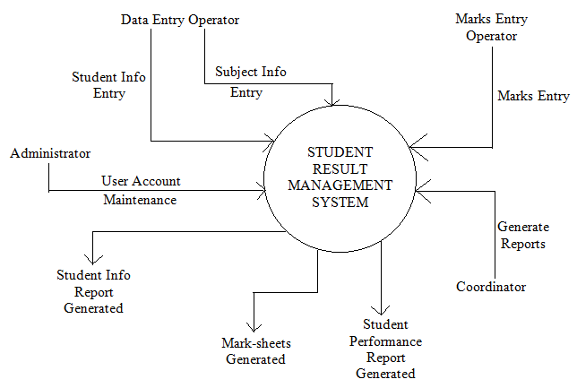

Level – 1 Data Flow Diagram:-
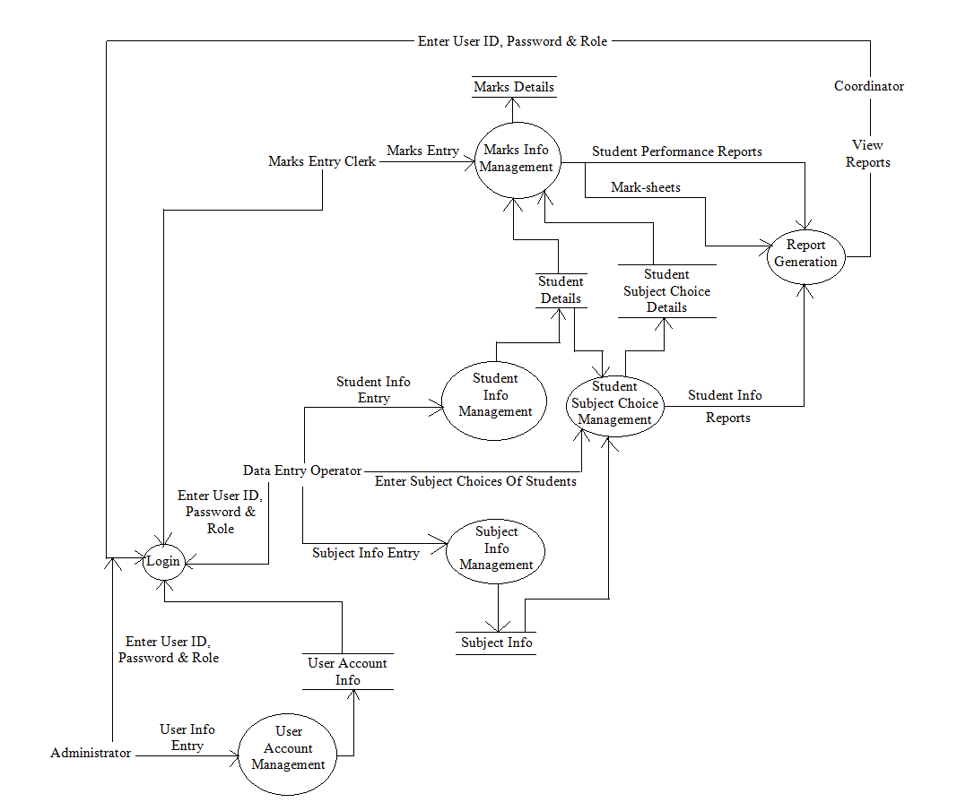CONCLUSION:-
Level – 0 and Level – 1 Data Flow Diagram (DFD) forSTUDENT RESULT MANAGEMENT SYSTEM have been drawn successfully.

EXERCISE – 7
AIM:-
To draw the State Chart Diagram forSTUDENT RESULT MANAGEMENT SYSTEM.
REQUIREMENTS:-
- SOFTWARE REQUIREMENT – Microsoft Word, Rational Rose Enterprise Edition
- HARDWARE REQUIREMENT – Computer, Keyboard, Mouse, CPU
THEORY:-
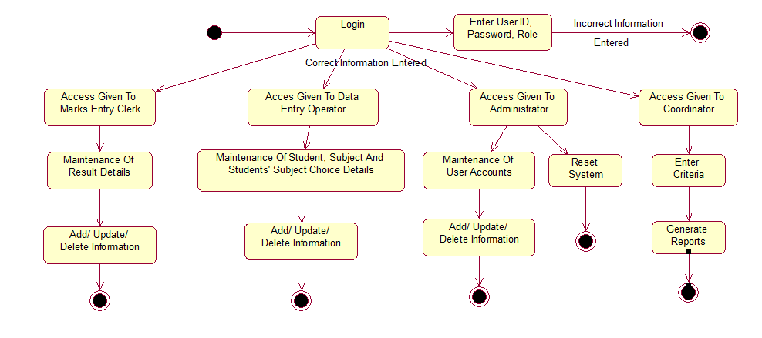
CONCLUSION:-
State Chart Diagram forSTUDENT RESULT MANAGEMENT SYSTEM has been drawn successfully.

EXERCISE – 8
AIM:-
To draw the Class Diagram forSTUDENT RESULT MANAGEMENT SYSTEM.
REQUIREMENTS:-
- SOFTWARE REQUIREMENT – Microsoft Word, Rational Rose Enterprise Edition
- HARDWARE REQUIREMENT – Computer, Keyboard, Mouse, CPU
THEORY:-
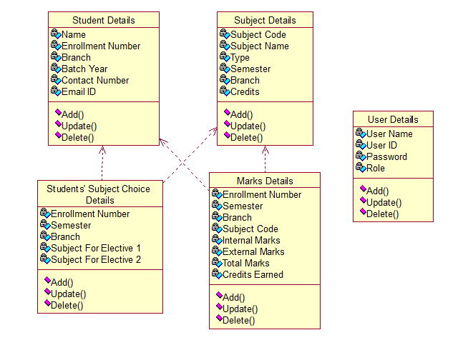
CONCLUSION:-
Class Diagram forSTUDENT RESULT MANAGEMENT SYSTEM has been drawn successfully.

EXERCISE – 9
AIM:-
To draw the Activity Diagram forSTUDENT RESULT MANAGEMENT SYSTEM.
REQUIREMENTS:-
- SOFTWARE REQUIREMENT – Microsoft Word, Rational Rose Enterprise Edition
- HARDWARE REQUIREMENT – Computer, Keyboard, Mouse, CPU
THEORY:-
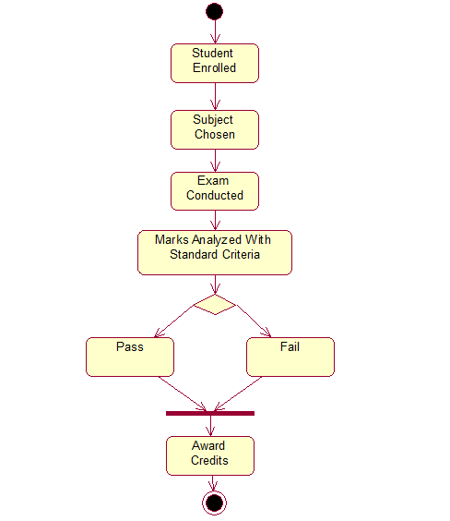

CONCLUSION:-
ActivityDiagram forSTUDENT RESULT MANAGEMENT SYSTEM has been drawn successfully.

EXERCISE – 10
AIM:-
To draw the Sequence Diagrams forSTUDENT RESULT MANAGEMENT SYSTEM.
REQUIREMENTS:-
- SOFTWARE REQUIREMENT – Microsoft Word, Rational Rose Enterprise Edition
- HARDWARE REQUIREMENT – Computer, Keyboard, Mouse, CPU
THEORY:-
(a) LOGIN
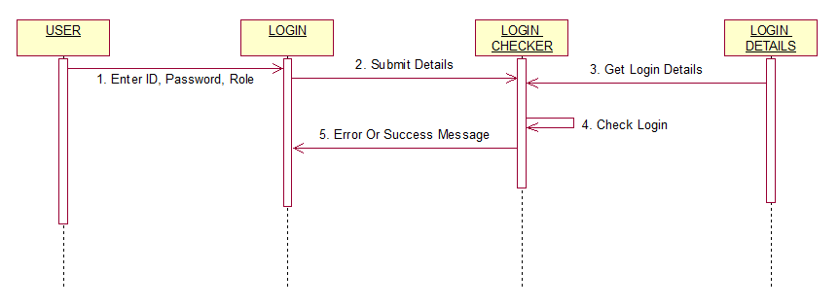
(b) MAINTAIN STUDENT INFORMATION
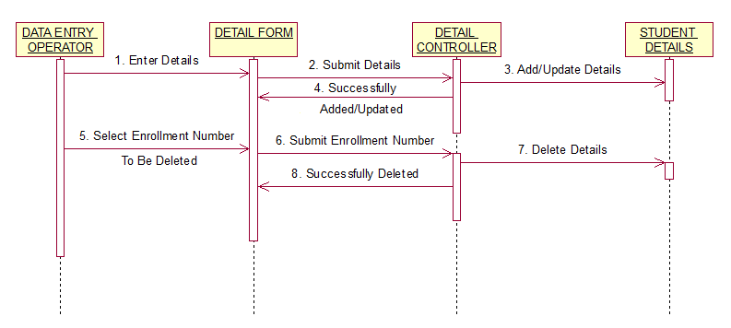
(c) MAINTAIN SUBJECT INFORMATION
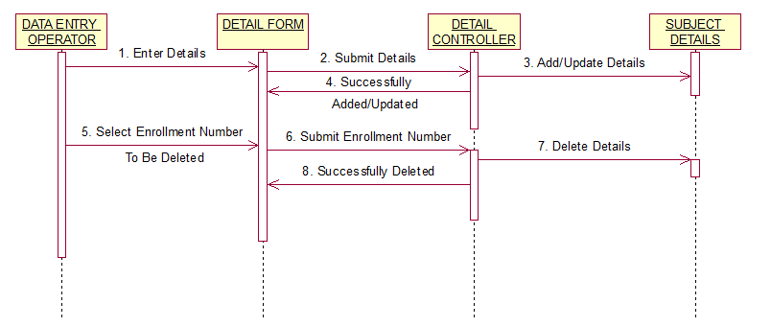
(d) MAINTAIN STUDENT’S SUBJECT CHOICE INFORMATION
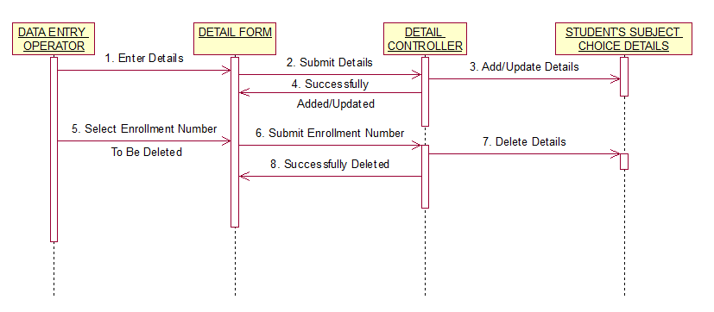

(e) MAINTAIN LOGIN INFORMATION
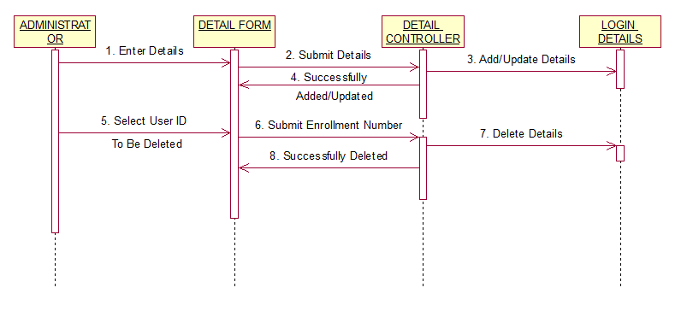
(f) MAINTAIN RESULT INFORMATION
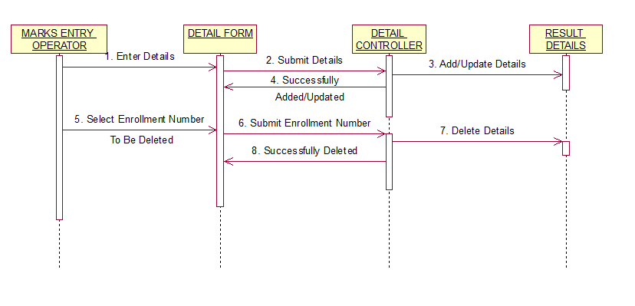

(g) GENERATE RESULTS
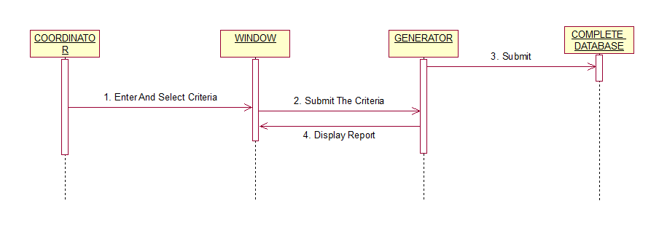
CONCLUSION:-
SequenceDiagrams forSTUDENT RESULT MANAGEMENT SYSTEM has been drawnsuccessfully.

EXERCISE – 11
AIM:-
To draw the Collaboration Diagrams forSTUDENT RESULT MANAGEMENT SYSTEM.
REQUIREMENTS:-
- SOFTWARE REQUIREMENT – Microsoft Word, Rational Rose Enterprise Edition
- HARDWARE REQUIREMENT – Computer, Keyboard, Mouse, CPU
THEORY:-
(a) LOGIN
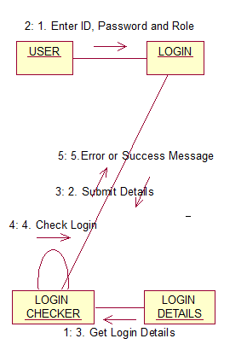

(b) MAINTAIN STUDENT INFORMATION
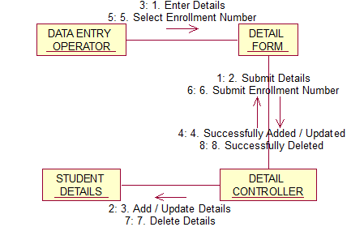
(c) MAINTAIN SUBJECT INFORMATION
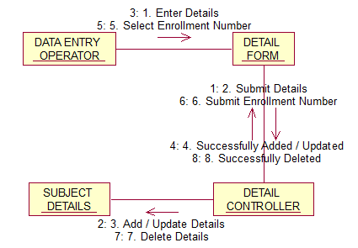

(d) MAINTAIN STUDENT’S SUBJECT CHOICE INFORMATION
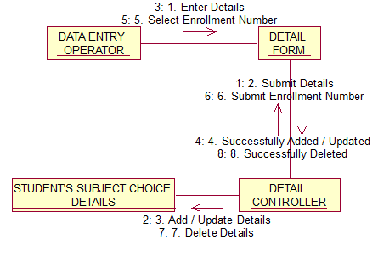
(e) MAINTAIN LOGIN INFORMATION
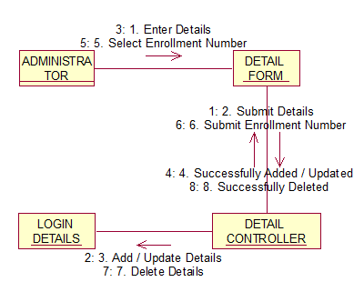

(f) MAINTAIN RESULT INFORMATION
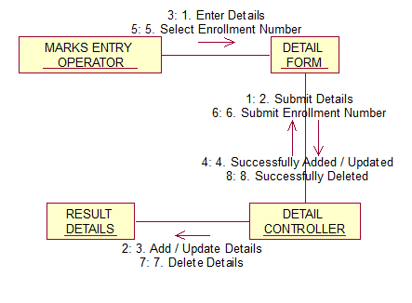
(g) GENERATE REPORTS
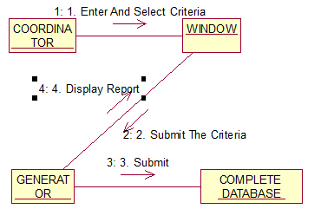
CONCLUSION:-
CollaborationDiagrams forSTUDENT RESULT MANAGEMENT SYSTEM has been drawn successfully.

